

**K. J. Somaiya College of Engineering, Mumbai-77**

(Somaiya Vidyavihar University)

**Name: Chandana Ramesh Galgali**

**Batch: P3-3 Roll No.: 16010422234**

**Experiment / ~~assignment~~ / ~~tutorial~~ No. 2**

**Grade: AA / AB / BB / BC / CC / CD /DD**

**Signature of the Staff In-charge with date**

| **TITLE:** Write a program to accept 3 numbers from the user and find the largest of the 3 numbers using   * If - else if - else * Ternary operator |
| --- |

**AIM:** Write a program to accept 3 numbers from the user and find the largest of the 3 numbers using:

If - else if - else

Ternary operator

**______________________________________________________________________ Expected Outcome of Experiment:** The user will enter 3 numbers and the largest of the three numbers will be printed on the screen as the output.

**_____________________________________________________________________ Books/ Journals/ Websites referred:**

1. Programming in C, second edition, Pradeep Dey and Manas Ghosh, Oxford University Press.

2. Programming in ANSI C, fifth edition, E Balagurusamy, Tata McGraw Hill. 3. Introduction to programming and problem solving , G. Michael Schneider ,Wiley India edition.

4. **http://cse.iitkgp.ac.in/~rkumar/pds-vlab/**

**_____________________________________________________________________ Problem Definition:**

Ask the user to input three numbers. Compare the three numbers to find the largest of them using:

1. Nested if-else statement

2. Using ternary operator

**Department of Science and Humanities**

Page No PIC Sem I/August-December 2022-23



**K. J. Somaiya College of Engineering, Mumbai-77**

(Somaiya Vidyavihar University)

**Flowchart:**

1.If-else if-else:



2. Ternary Operator:



**Department of Science and Humanities**

Page No PIC Sem I/August-December 2022-23



**K. J. Somaiya College of Engineering, Mumbai-77**

(Somaiya Vidyavihar University)

**Implementation details:**

1.If-else if-else:

#include<stdio.h>

void main()

{

int a,b,c;

printf("Enter the first number: ");

scanf("%d", &a);

printf("\nEnter the second number: ");

scanf("%d", &b);

printf("\nEnter the third number: ");

scanf("%d", &c);

if(a>b && a>c)

{

printf("\nThe first number is the largest: %d",a);

}

else if(b>a && b>c)

{

printf("\nThe second number is the largest: %d",b);

}

else

{

printf("\nThe third number is the largest: %d",c);

}

}

2. Using ternary operator:

#include<stdio.h>

void main()

{

int a,b,c;

printf("Enter the first number: ");

scanf("%d",&a);

printf("\nEnter the second number: ");

scanf("%d",&b);

printf("\nEnter the third number: ");

scanf("%d",&c);

(a>b && a>c)? printf("\nThe first no. is the largest: %d",a):printf("\nThe first no. is not the largest.");

(b>a && b>c)? printf("\nThe second no. is the largest: %d",b):printf("\nThe second no. is not the largest.");

(c>b && c>a)? printf("\nThe third no. is the largest: %d",c):printf("\nThe third no. is not the largest.");

}

**Department of Science and Humanities**

Page No PIC Sem I/August-December 2022-23



**K. J. Somaiya College of Engineering, Mumbai-77**

(Somaiya Vidyavihar University)

**Output(s):**

1.If-else if-else:

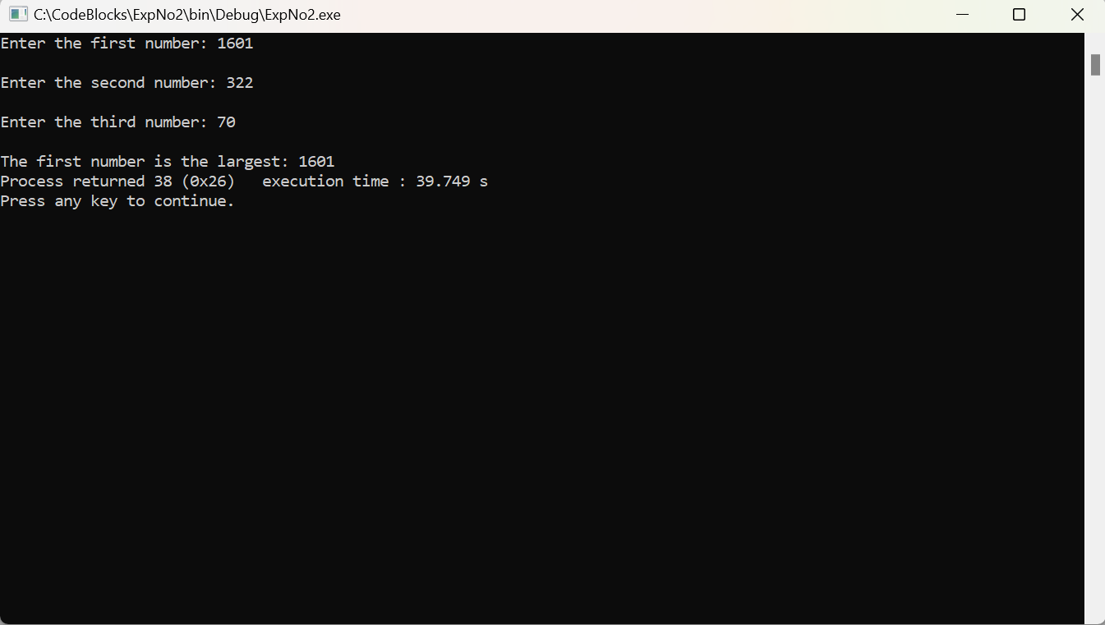

2.Using ternary operator:

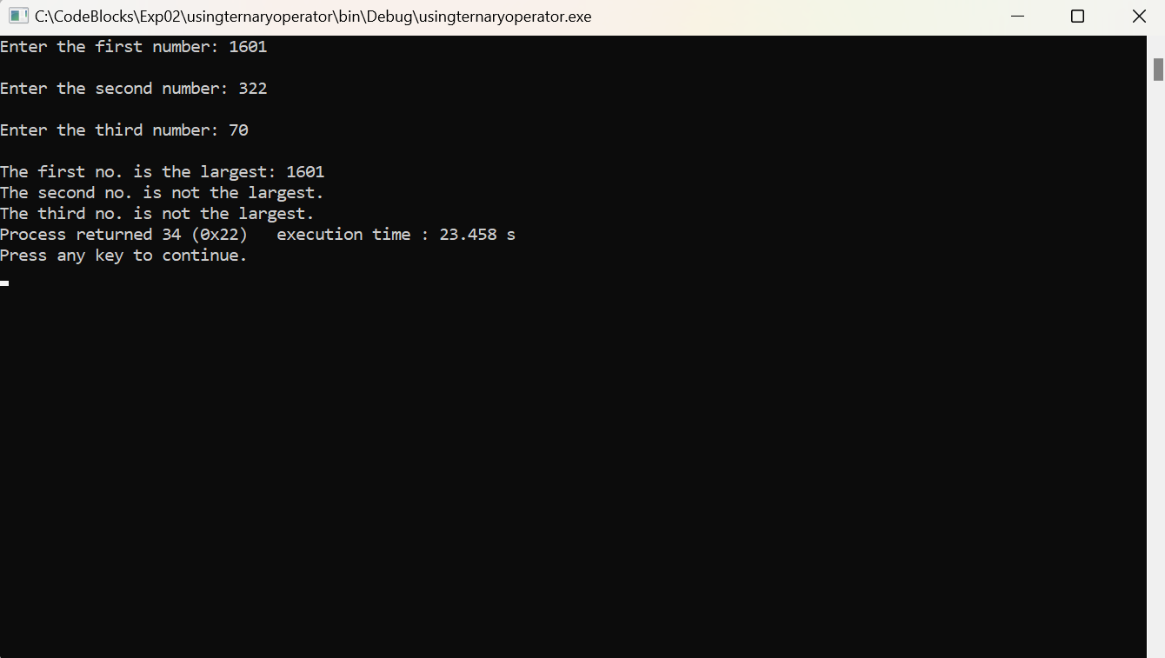

**Conclusion:** The largest number was therefore correctly printed as the output, from the three numbers inputted by the user. The numbers that were inputted were compared using the nested if-else statement and the ternary operator in the code and then the largest number of them was thus found.

**Post Lab Descriptive Questions:**

**1. Explain bitwise operators with examples.**

**Ans:** Bitwise operator works on bits and performs bit-by-bit operation. The truth tables for &, |, and ^ is as follows −

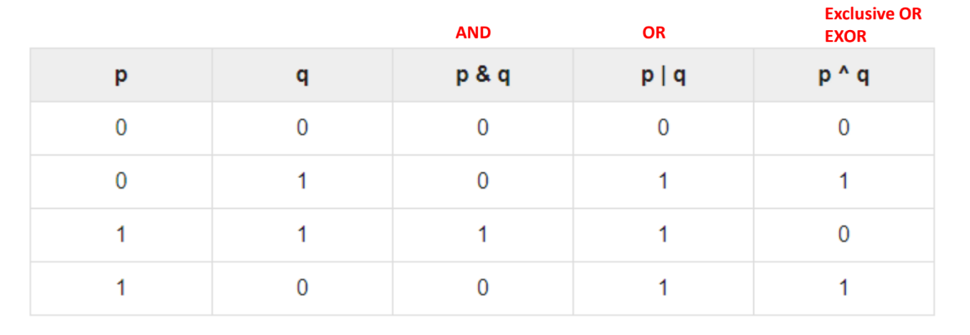

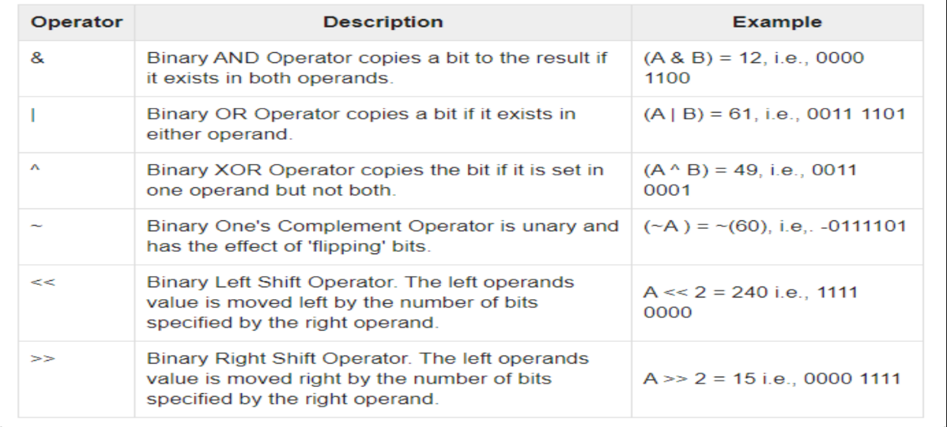

**2. Write a code snippet to perform left shifting of bits by some positions.**

**Ans:** #include <stdio.h>

void main()

{

int x = 60; /* 60 = 0011 1100 */

int y = 0;

y = x << 2; /* 240 = 1111 0000 */

printf("Value of y is: %d\n", y );

}

**3. Write associative rules and the precedence table of various operators.**

**Ans:** 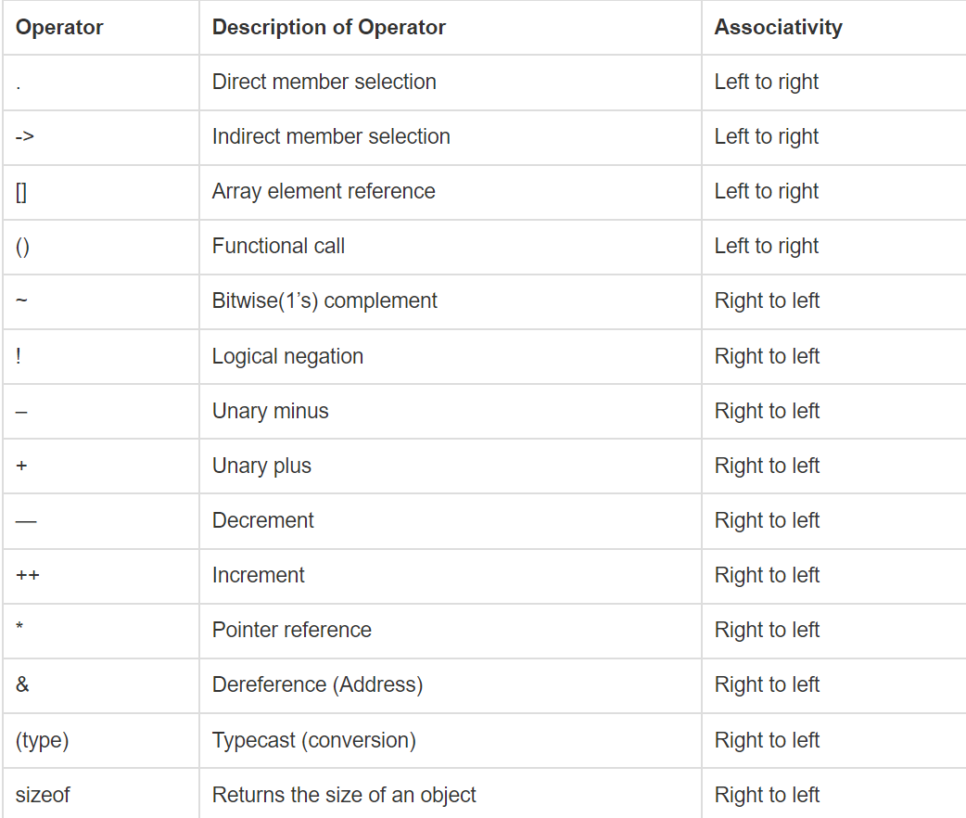

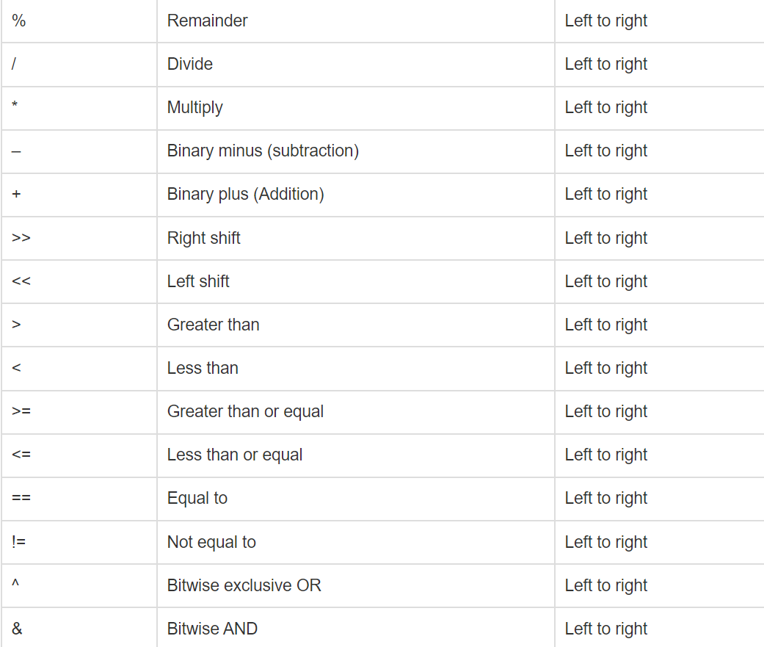

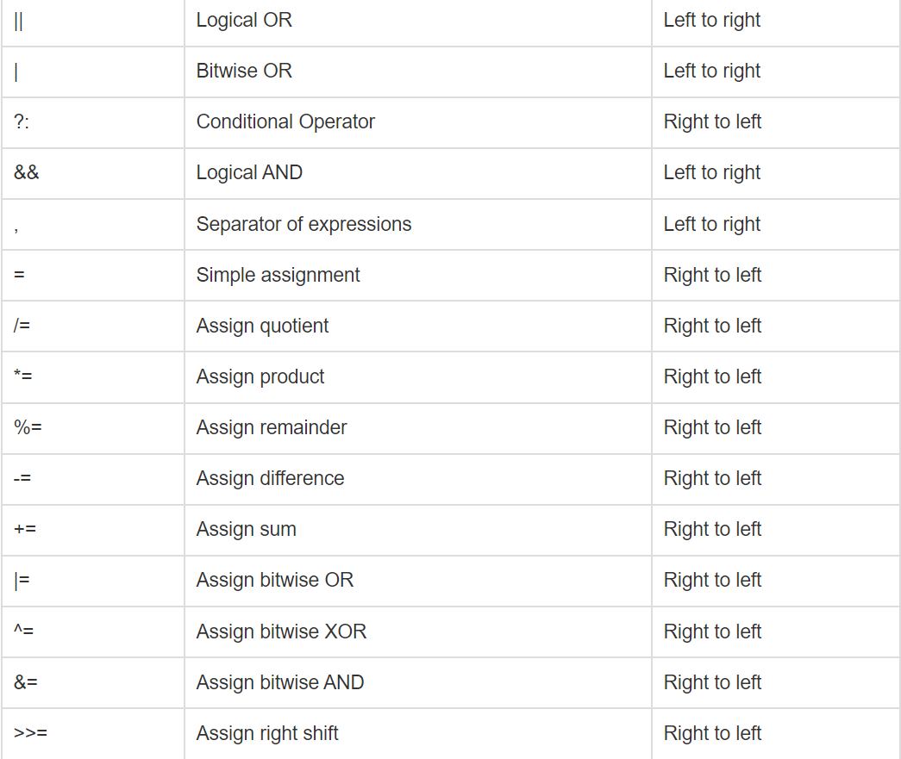

**4. What are different storage class specifiers in C?**

**Ans:** A variable given in a C program will have two of the properties: storage class and type. Here, type refers to any given variable’s data type, while the storage class determines that very variable’s lifetime, visibility, and also its scope.

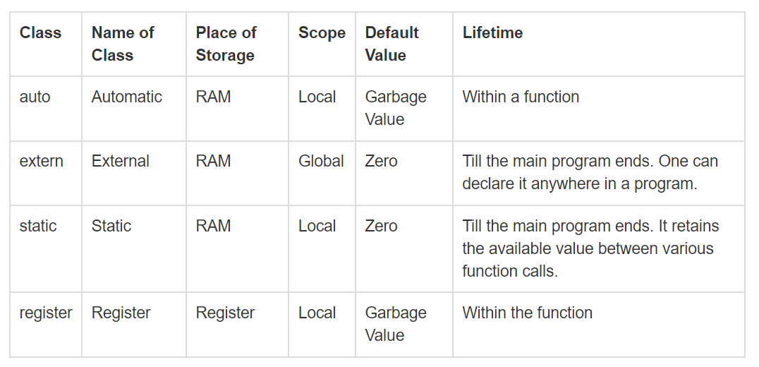

**Date: _____________ Signature of faculty in-charge**

**Department of Science and Humanities**

Page No PIC Sem I/August-December 2022-23